A REPORT ON TESTING OF EM386/EM386-C METER

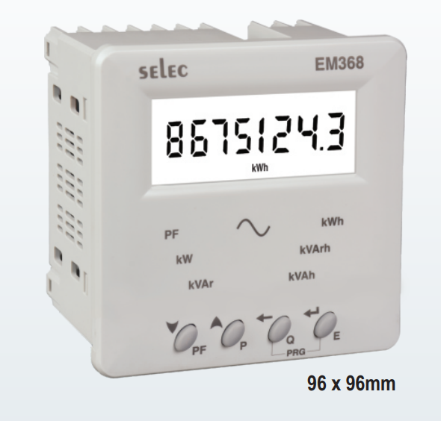

**TABLE OF CONTENTS:-**

* INTRODUCTION
* TECHNICAL SPECIFICATION
* SERIAL COMMUNICATION
* TERMINAL CONNECTION
* WIRING DIAGRAM
* CONNECTION DIAGRAM
* STEPS FOR CONNECTION
* STEPS FOR CT AND METER CONFIGURATION
* READINGS
* CALCULATION
* AMI READINGS
* ERROR
* OBSERVATION
* RESULT
* OPEN QUESTIONS

**Introduction:**-

The EM368/EM368-C Meter can be used for measurement of Voltage, current, Active and Reactive power. The Meter utilizes RS485 Serial communication protocol. The Meter has CT, PT Primary and Secondary. The meter input wiring can be 3Ø -4 wire, 3Ø-3 wire, 2Ø – 3 wire and 1Ø-2 wire.

**Technical Specification:-**

| Sr.No | Parameter |  |
| --- | --- | --- |
| 1 | Rated input voltage | 11 to 300V AC(L-N)  19 to 519V AC (L-L) |
| 2 | Frequency range | 45 to 65Hz |
| 3 | Rated input current | Nominal 5A AC (Min-11 mA, Max -6A) |

**The details of Serial communication are as follows:-**

| Pulse Output | Voltage Range : External 24v DC  Current Capacity : 100mA  Pulse Width : 100ms ± 5ms |
| --- | --- |
| Communication Interface and Protocol | RS 485 and MODBUS RTU |
| Communication Address | 1 to 255 |
| Transmission Mode | Half Duplex |
| Transmission Distance | 500m Maximum |
| Transmission Speed | 300,600,1200,2400,4800,9600,19200 (in bps) |
| Parity | None , Odd , Even |
| Stop Bits | 1 or 2 |
| Response Time | 100ms (max and independent of baud rate ) |

**Terminal Connection :-**

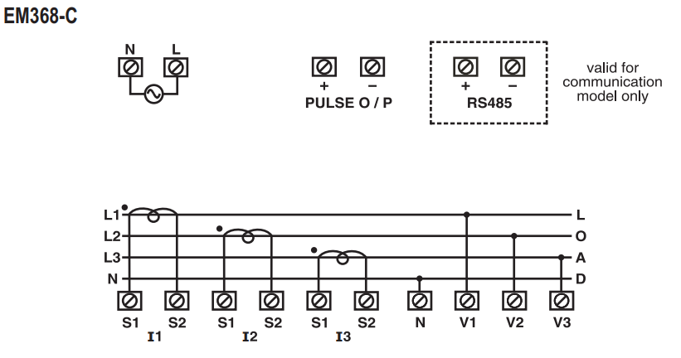

**Connection Diagram:-**

1-PHASE 2 WIRE CONNECTION

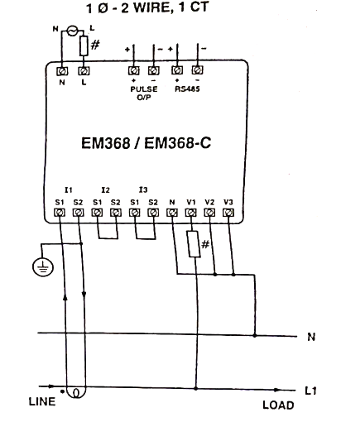

3-PHASE - 4 WIRE CONNECTION

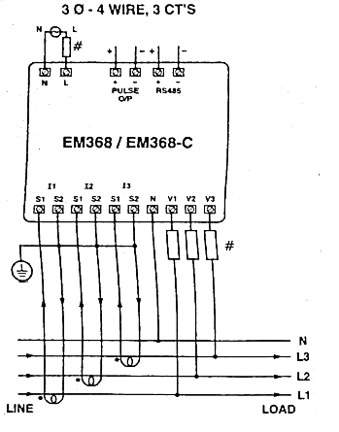

3-PHASE -4 WIRE CONNECTION

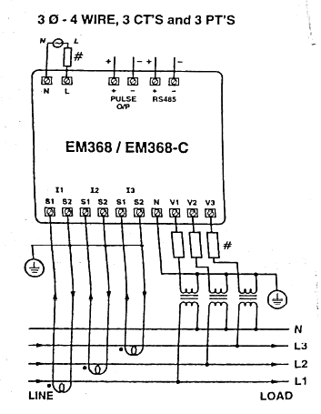

3-PHASE -3 WIRE CONNECTION

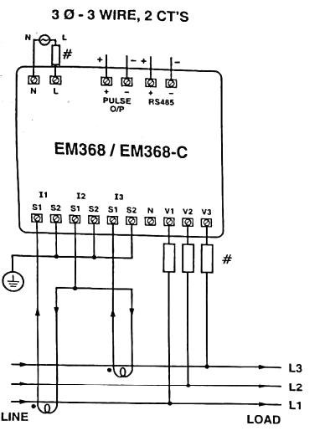

2-PHASE 3 WIRE CONNECTION

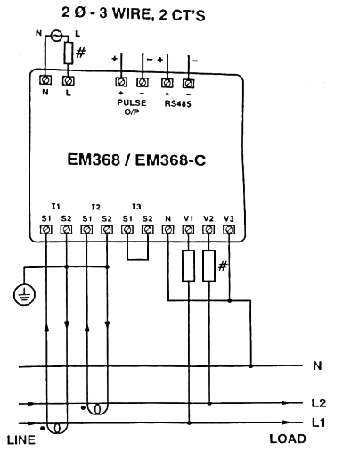

| MODBUS REGISTER ADDRESS LIST | | | | | | |
| --- | --- | --- | --- | --- | --- | --- |
| **ADDRESS** | **HEX ADDRESS** | **PARAMETER** | **LENGTH**  **(REGISTER)** | | **DATA STRUCTURE** | |
| **30000** | **0x00** | **Active Energy** | **2** | | **FLOAT** | |
| **30002** | **0X02** | **Apparent Energy** | **2** | | **FLOAT** | |
| **30004** | **0X04** | **Reactive Energy** | **2** | | **FLOAT** | |
| **30006** | **0X06** | **Power Factor Phase 1** | **2** | | **FLOAT** | |
| **30008** | **0X08** | **Power Factor Phase 2** | **2** | | **FLOAT** | |
| **30010** | **0X0A** | **Power Factor Phase 3** | **2** | | **FLOAT** | |
| **30012** | **0X0C** | **Average Power Factor** | **2** | | **FLOAT** | |
| **30014** | **0X0E** | **Total KW** | **2** | | **FLOAT** | |
| **30016** | **0X10** | **Total KVAr** | **2** | | **FLOAT** | |
| READABLE / WRITEABLE PARAMETERS FROM EM368-C | | | | | | |
| **ADDRESS** | **HEX ADDRESS** | **PARAMETER** | **RANGE** | | **LENGTH** | **DATA STRUCTURE** |
|  |  |  | **MIN** | **MAX** |  |  |
| **40000** | **0X00** | **New Password** | **1** | **9998** | **1** | **INTEGER** |
| **40001** | **0X01** | **N/W Selection** | **Value** | **Meaning** |  |  |
|  |  |  | **0** | **3P-4W** | **1** | **INTEGER** |
|  |  |  | **1** | **3P-3W** |  |  |
| **40002** | **0X02** | **CT Secondary** | **Write Value** | **CT Secondary** | **1** | **INTEGER** |
|  |  |  | **1** | **1A** |  |  |
|  |  |  | **5** | **5A** |  |  |
| **40003** | **0X03** | **CT Primary** | **5A(CT SEC=5A)** | **10000A** | **1** | **INTEGER** |
| **40003** | **0X03** | **CT Primary** | **1A(CT SEC=1A)** | **10000A** | **1** | **INTEGER** |
| **40004** | **0X04** | **PT Secondary** | **100V** | **500V** | **1** | **INTEGER** |
| **40005** | **0X05** | **PT Primary** | **100V** | **500KV** | **2** | **INTEGER** |
| **40008** | **0X08** | **Slave Id** | **1** | **255** | **1** | **INTEGER** |
| **40009** | **0X09** | **Baud Rate** | **Value** | **Baud Rate(bps)** | **1** | **INTEGER** |
|  |  |  | **0X00** | **300** |  |  |
|  |  |  | **0X01** | **600** |  |  |
|  |  |  | **0X02** | **1200** |  |  |
|  |  |  | **0X03** | **2400** |  |  |
|  |  |  | **0X04** | **4800** |  |  |
|  |  |  | **0X05** | **9600** |  |  |
|  |  |  |  | **0X06** |  |  |
| **40010** | **0X0A** | **Parity** | **Value** | **Parity** |  |  |
|  |  |  | **0x00** | **None** | **1** | **INTEGER** |
|  |  |  | **0x01** | **Odd** |  |  |
|  |  |  | **0x02** | **Even** |  |  |
| **40011** | **0X0B** | **Stop bits** | **Value** | **Stop Bits** | **1** | **INTEGER** |
|  |  |  | **0X00** | **1** |  |  |
|  |  |  | **0X01** | **2** |  |  |
|  |  |  | **Value** | **Meaning** |  |  |
| **40012** | **0X0C** |  | **1** | **Reset Active Energy** | **1** | **INTEGER** |
| **40013** | **0X0D** |  | **1** | **Reset Apparent Energy** | **1** | **INTEGER** |
| **40014** | **0X0E** |  | **1** | **Reset Reactive Energy** | **1** | **INTEGER** |

**STEPS FOR CT AND METER:-**

1. Pass Phase terminal of supply to the middle of the CT and take one wound on the CT.
2. Then Connect CT secondary wires to the Meter.
3. Turn ON the meter.
4. Turn ON CT.

**STEPS FOR CONNECTION:-**

1. Read the Instruction Manual.
2. Connect CT to the Meter.
3. Connect Wires of Meter given in the Connection Diagram.
4. Connect Meter to the Laptop.
5. Open Modbus Poll Application in Laptop.
6. Connect Modbus Poll and meter via RS 485/RS 232 or TCP/IP.
7. Turn On Meter.
8. Turn On CT.
9. Turn On Load.
10. Check the reading of parameters on meter as well as on laptop screen (ModbusPoll) .

**READINGS:-**

1. **First Reading:-**

| **Time ON** | **Time OFF** | **Previous Reading** | **Meter**  **Reading** | **Modbus Reading** | **Actual Reading** |
| --- | --- | --- | --- | --- | --- |
| **2:35** | **2:41** | **0.2** | **0.3** | **0.3** | **0.3** |

1. **Second Reading:-**

| **Time ON** | **Time OFF** | **Previous Reading** | **Meter**  **Reading** | **Modbus Reading** | **Actual Reading** |
| --- | --- | --- | --- | --- | --- |
| **2:55** | **3:01** | **0.3** | **0.4** | **0.4** | **0.4** |

1. **Third Reading:-**

| **Time ON** | **Time OFF** | **Previous Reading** | **Meter**  **Reading** | **Modbus Reading** | **Actual Reading** |
| --- | --- | --- | --- | --- | --- |
| **3:07** | **3:13** | **0.4** | **0.5** | **0.5** | **0.5** |

1. **Fourth Reading:-**

| **Time ON** | **Time OFF** | **Previous Reading** | **Meter**  **Reading** | **Modbus Reading** | **Actual Reading** |
| --- | --- | --- | --- | --- | --- |
| **3:19** | **3:25** | **0.5** | **0.6** | **0.6** | **0.6** |

1. **Fifth Reading:-**

| **Time ON** | **Time OFF** | **Previous Reading** | **Meter**  **Reading** | **Modbus Reading** | **Actual Reading** |
| --- | --- | --- | --- | --- | --- |
| **3:31** | **3:37** | **0.6** | **0.7** | **0.7** | **0.7** |

**CALCULATION:-**

1. **First Reading:-**

* Voltage = 235 Volts
* Current = 4 Amp.
* PF = 1
* KW =Voltage * Current * PF

= 235*4*1= 940

* KWH = [KW* time(Min.)/60}]/1000

= (235 * 4*(6/60))/1000

= 0.094

* Calculated Value = Previous Reading + KWH

= 0.2+0.094 = 0.294

1. **Second Reading:-**

* Voltage = 235 Volts
* Current = 4 Amp.
* PF = 1
* KW =Voltage * Current * PF

= 235*4*1= 940

* KWH = [KW* time(Min.)/60}]/1000

= (235 * 4*(6/60))/1000

= 0.094

* Calculated Value = Previous Reading + KWH

= 0.3+0.094 = 0.394

1. **Third Reading:-**

* Voltage = 235 Volts
* Current = 4 Amp.
* PF = 1
* KW =Voltage * Current * PF

= 235*4*1= 940

* KWH = [KW* time(Min.)/60}]/1000

= (235 * 4*(6/60))/1000

= 0.094

* Calculated Value = Previous Reading + KWH

= 0.4+0.094 = 0.494

1. **Fourth Reading:-**

* Voltage = 235 Volts
* Current = 4 Amp.
* PF = 1
* KW =Voltage * Current * PF

= 235*4*1=940

* KWH = [KW* time(Min.)/60}]/1000

= (235 * 4*(6/60))/1000

= 0.094

* Calculated Value = Previous Reading + KWH

= 0.5+0.094 = 0.594

1. **fifth reading:-**

* Voltage = 235 Volts
* Current = 4 Amp.
* PF = 1
* KW =Voltage * Current * PF

= 235*4*1=940

* KWH = [KW* time(Min.)/60}]/1000

= (235 * 4*(6/60))/1000

= 0.094

* Calculated Value = Previous Reading + KWH

= 0.6+0.094 = 0.694

**ERROR:-**

| **Sr. No.** | **Previous**  **Reading** | **Actual**  **Value** | **Calculated**  **Value** | **Error**  **(Actual Value- Cal.Value)** |
| --- | --- | --- | --- | --- |
| **1** | **0.2** | **0.3** | **0.294** | **0.006** |
| **2** | **0.3** | **0.4** | **0.394** | **0.006** |
| **3** | **0.4** | **0.5** | **0.494** | **0.006** |
| **4** | **0.5** | **0.6** | **0.594** | **0.006** |
| **5** | **0.6** | **0.7** | **0.694** | **0.006** |

**OBSERVATION:-**

1. Connect all the devices like CT and EM with the help of user manual and connect the EM with the Modbus poll software with the help of a connector.
2. With the help of a data sheet of EM which is given above enter the value of the register.
3. Now we have to connect the device with load (inductive load) with lagging pf.
4. We observe that on connecting the load the EM starts reading the kw reading and the respected reading of kw is taken on modbus software where we found that it is giving the same reading of KW,current and voltage.
5. We are measuring current and voltage reading with the help of clamp-on-metre. where we would say that the same reading is coming with respect to modbus software.
6. and then we tried changing the CT.
7. Now on changing CT the similar result is found on modbus software and on EM.
8. On connecting the new CT we observed that the KW reading is not reset and the reading continues from that same reading.
9. On interchanging the terminal of s1 and s2 we found that the reading of power and current are coming negative bcz of exchanging the terminal of the secondary side of CT.
10. Now on reversing the primary side on CT we again observed that the valve of current goes negative hence the current direction has been reversed and the same reading we observed in modbus lib software.

So those are the observations that we have got by performing tests on CT and EM.

**RESULT:-**

**OPEN QUESTIONS:-**

1. On reversing the direction of both terminals of CT i.e primary as well as secondary side why we are still getting power negative and current become positive why?